**What is Prometheus**

* Prometheus is a open source Linux Server Monitoring tool mainly used for metrics monitoring, event monitoring, alert management, etc.
* Prometheus has changed the way of monitoring systems and that is why it has become the Top-Level project of Cloud Native Computing Foundation (CNCF).
* Prometheus uses a powerful query language i.e. “PromQL”.
* In Prometheus tabs are on and handles hundreds of services and microservices.
* Prometheus use multiple modes used for graphing and dashboarding support.

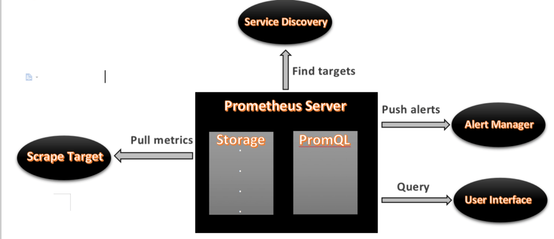

* As above we can see an architecture of Prometheus monitoring tool.
* We made a basic design to understand it easily for you people

## ****Prometheus Component****s

### ****1. Prometheus Server****

* Prometheus server is a first component of Prometheus architecture.
* Prometheus server is a core of Prometheus architecture which is divided into several parts like Storage, PromQL, HTTP server, etc.
* In Prometheus server data is scraped from the target nodes and then stored int the database.

**1.a. Storage**

* Storage in Prometheus server has a local on disk storge.
* Prometheus has many interfaces that allow integrating with remote storage systems.

**1.b. PromQL**

* Prometheus uses its own query language i.e. PromQL which is very powerful querying language.
* PromQL allows the user to select and aggregate the data

### ****2. Service Discovery****

* Next and very important component of Prometheus Server is the Service Discovery.
* With the help of Service discovery the services are identified which are need to scraped.
* To Pull metrics, identification of services and finding the targets are compulsory needed.
* Through Service discovery we monitor the entities and can also locate its targets.

### ****3. Scrape Target****

* Once the services are identified and the targets are ready then we can pull metrics from it and can scrape the target.
* We can export the data of end point using node exporters.
* Once the metrics or other data is pulled, Prometheus stores it in a local storage.

### ****4. Alert Manager****

* Alert Manager handles the alerts which may occurs during the session.
* Alert manager handles all the alerts which are sent by Prometheus server.
* Alert manager is one of the very useful component of Prometheus tool.
* If in case any big error or any issue occurs, alert manager manage those alerts and contact with human via E-mail, Text Messages, On-call, or any other chat application service.

### ****5. User Interface****

* User interface is also a important component as it builds a bridge between the user and the system.
* In Prometheus, user interface are note that much user friendly and can be used till graph queries.
* For good exclusive dashboards Prometheus works together with Grafana (visualization tool).
* Using Grafana over Prometheus to visualize properly we can use custom dashboards.
* Grafana dashboards displays via pie charts, line charts, tables, good data graphs of CPU usage, RAM utilization, network load, etc with indicators.
* Grafana supports and run with Prometheus by querying language i.e. PromQL.
* To fetch data from Prometheus and to display the results on Grafana dashboards PromQL is used.

**What is Grafana**

* Grafana is a free and open source visualization tool mostly used with Prometheus to which monitor metrics.
* Grafana provides various dashboards, charts, graphs, alerts for the particular data source.
* Grafana allows us to query, visualize, explore metrics and set alerts for the data source which can be a system, server, nodes, cluster, etc.
* We can also create our own dynamic dashboard for visualization and monitoring.
* We can save the dashboard and can even share with our team members which is one of the main advantage of Grafana.

**What is Node Exporter**

* Node exporter is one of the Prometheus exporters which is used to expose servers or system OS metrics.
* With the help of Node exporter we can expose various resources of the system like RAM, CPU utilization, Memory Utilization, disk space.
* Node exporter runs as a system service which gathers the metrics of your system and that gathered metrics is displayed with the help of Grafana visualization tool

**Prerequisites**

* Ubuntu with 22.04 Version
* Root user account with **sudo** privilege.
* Prometheus system user and group.
* Sufficient storage on your system and good internet connectivity.
* Ports Required- **9090 (Prometheus), 3000 (Grafana), 9100 (Node Exporter)**